

AI Assignment 2

[Document subtitle]



March 23, 2025

Fatima SEEMAB AND AZKA QADIR

## Github Link Code:

https://github.com/FatimaSeemab/GAN.git

## Experimentation

Architecture of generator and discriminator

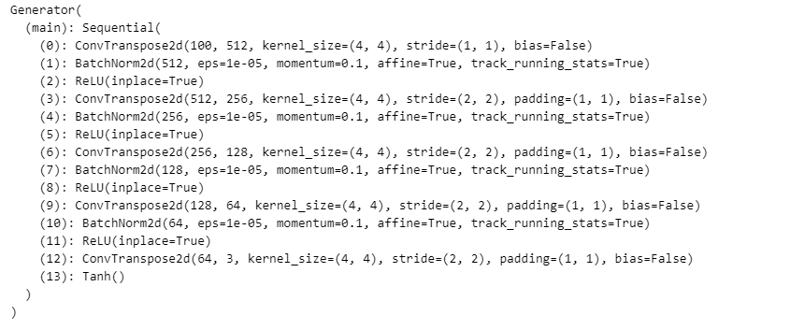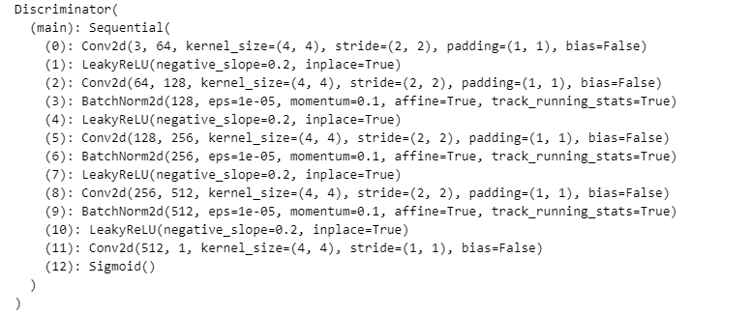

First, we experimented it for 20 epochs, generator loss was decreasing gradually. After some epochs, loss started to become increasing. So we set real label from 1 to 0.9. Generator started to learn.

With real_label 1.0

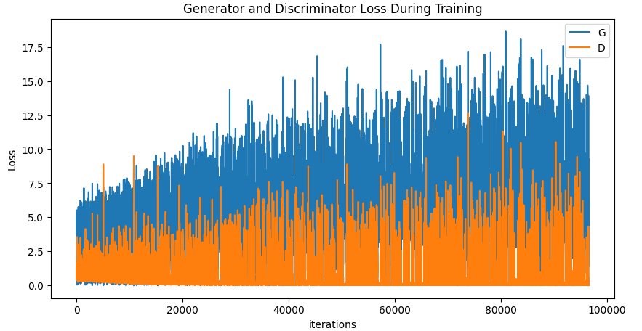

With real_label 0.9  
